Note: Include this page only when adding / amending / deleting a document. If using this document as a record, this Revision History page can be omitted.

REVISION HISTORY

Revision no | Date | Description of Changes | Reason for Revision | Revised by | Approved by
00 | Mar. 14, 2014 | Initial document | To simplify BDM’s process | RDPlacido
01 | Apr. 8, 2016 | Added disclaimer when printing the document | For document control | RCGanal | RTMonzon
02 | Nov. 17, 2017 | Revised Covered Activities under Scope | Some activities are not applicable | CEYet | RTMonzon
TM-BR-MG- 11 Rev02, 10302015
- Objective:

To support the company’s marketing, sales and account management functions by providing information on and initiating contact with the customer to further enhance the company’s relationship with its customers, partners and other stakeholders.

- Scope:

This procedure defines the actions & responsibilities of the Marketing Assistant, Account Managers and other concerned units in enhancing good relationship with customers and partners.

This covers the following activities:
- Release of Email Newsletter as when needed
- Birthday greetings/gift giving
- Christmas greetings/gift giving
- Greetings / Gift giving for other significant events

- Definition of Terms:

None

- Procedure Details:

RESPONSIBLE | ACTIVITY | INTERFACE
Marketing Assistant | 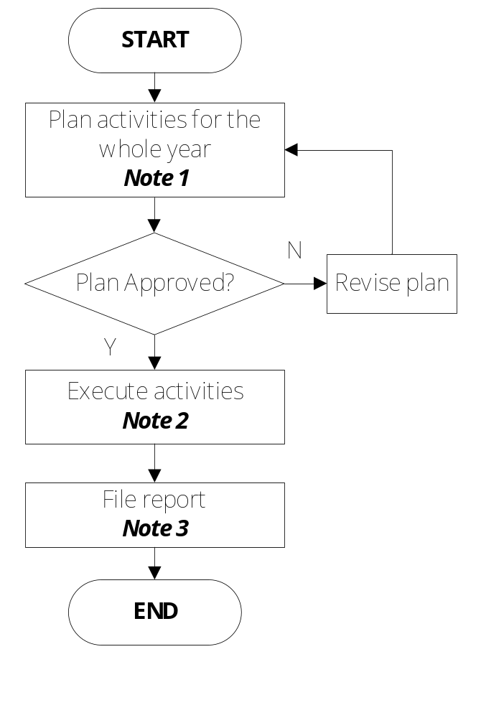 | Birthday Gift Plan & report  Christmas Gift Plan  Email Newsletter Plan & Report  ExeCom  Birthday Gift Plan & report  Christmas Gift Report  Email Newsletter Plan & Report

Notes:
- Use the designated supporting documents assigned per activity:
  - Customer Intimacy
    - Customer Intimacy Guideline
    - Birthday Gift Plan & Report
    - Christmas Gift Plan Template
    - Christmas Gift Report Template
  - Email Newsletter
    - Email Newsletter Plan & Report
- Execute activities as planned. Use the designated supporting documents assigned per activity.
- Use the designated supporting documents assigned per activity. Include results this in the KPM Monitoring Report.

- References:

- Customer Intimacy Guideline
- Birthday Gift Plan & Report
- Christmas Gift Plan Template
- Christmas Gift Report Template
- Email Newsletter Plan & Report

- Quality Records:

- Birthday Gift Plan & Report
- Christmas Gift Plan
- Christmas Gift Report
- Email Newsletter Plan & Report

